Lucy Maud

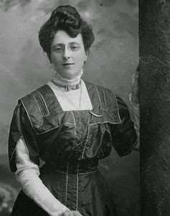

ANNE OF GREEN GRABLES

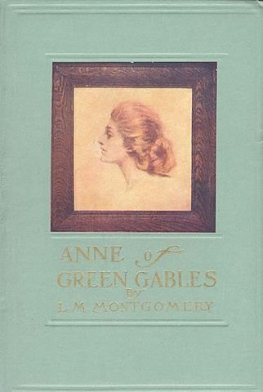

Anne of Green Gable*s* is a 1908 novel by Canadian author [Lucy Maud Montgomery](https://en.wikipedia.org/wiki/Lucy_Maud_Montgomery" \o "Lucy Maud Montgomery) (published as L. M. Montgomery). Written for all ages, it has been considered a classic children's novel since the mid-20th century. Set in the late 19th century, the novel recounts the adventures of [Anne Shirley](https://en.wikipedia.org/wiki/Anne_Shirley" \o "Anne Shirley), an 11-year-old [orphan](https://en.wikipedia.org/wiki/Orphan" \o "Orphan) girl, who is mistakenly sent to two middle-aged siblings, Matthew and Marilla Cuthbert, who had originally intended to [adopt](https://en.wikipedia.org/wiki/Adopt" \o "Adopt) a boy to help them on their farm in the fictional town of Avonlea in [Prince Edward Island](https://en.wikipedia.org/wiki/Prince_Edward_Island" \o "Prince Edward Island), [Canada](https://en.wikipedia.org/wiki/Canada" \o "Canada). The novel recounts how Anne makes her way through life with the Cuthberts, in school, and within the town.

ANNE OF AVONLEA

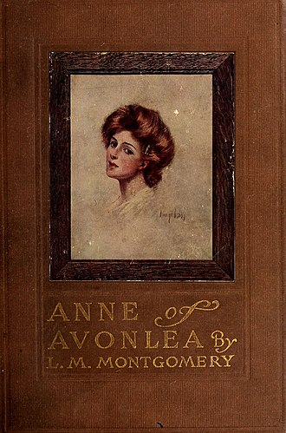

Following [Anne of Green Gables](https://en.wikipedia.org/wiki/Anne_of_Green_Gables" \o "Anne of Green Gables) (1908), the book covers the second chapter in the life of [Anne Shirley](https://en.wikipedia.org/wiki/Anne_Shirley" \o "Anne Shirley). This book follows Anne from the age of 16 to 18, during the two years that she teaches at Avonlea school. It includes many of the characters from *[Anne of Green Gables](https://en.wikipedia.org/wiki/Anne_of_Green_Gables" \o "Anne of Green Gables)*, as well as new ones like Mr. Harrison, Miss Lavendar Lewis, Paul Irving, and the twins Dora and Davy.

Anne is no longer simply "of Green Gables" as she was in the previous book, but now takes her place among the "important" people (and the "grown up" people) of Avonlea society, as its only schoolteacher. She is also a founding member of the A.V.I.S. (the Avonlea Village Improvement Society), which tries to improve (with questionable results) the Avonlea landscape.

ANNE OF THE ISLAND

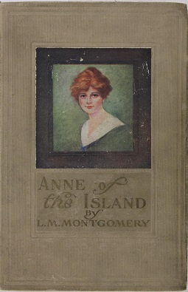

Anne leaves Green Gables and her work as a teacher in [Avonlea](https://en.wikipedia.org/wiki/Avonlea_(Anne_of_Green_Gables)" \o "Avonlea (Anne of Green Gables)) to pursue her original dream (which she gave up in *[Anne of Green Gables](https://en.wikipedia.org/wiki/Anne_of_Green_Gables" \o "Anne of Green Gables)*) of taking further education at Redmond College in Kingsport, Nova Scotia. Gilbert Blythe and Charlie Sloane enroll as well, as does Anne's friend from Queen's Academy, Priscilla Grant. During her first week of school, Anne befriends Philippa Gordon, a beautiful girl whose frivolous ways charm her. Philippa (Phil for short) also happens to be from Anne's birthplace in Bolingbroke, [Nova Scotia](https://en.wikipedia.org/wiki/Nova_Scotia" \o "Nova Scotia).

ANNE OF WINDY POPLARS

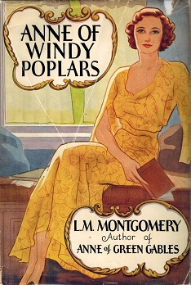

Anne of Windy Poplars—published as Anne of Windy Willows in the UK, Australia, and Japan—is an [epistolary novel](https://en.wikipedia.org/wiki/Epistolary_novel" \o "Epistolary novel) by Canadian author [L. M. Montgomery](https://en.wikipedia.org/wiki/L._M._Montgomery" \o "L. M. Montgomery). First published in 1936 by [McClelland and Stewart](https://en.wikipedia.org/wiki/McClelland_and_Stewart" \o "McClelland and Stewart), it details [Anne Shirley](https://en.wikipedia.org/wiki/Anne_Shirley" \o "Anne Shirley)'s experiences while serving as principal of a high school in [Summerside, Prince Edward Island](https://en.wikipedia.org/wiki/Summerside,_Prince_Edward_Island" \o "Summerside, Prince Edward Island) over three years. A large portion of the novel is presented through letters Anne writes to her fiancé, [Gilbert Blythe](https://en.wikipedia.org/wiki/Gilbert_Blythe" \o "Gilbert Blythe). Chronologically, the book is fourth in the series, but it was the seventh book written.

ANNE OF INGLESIDE

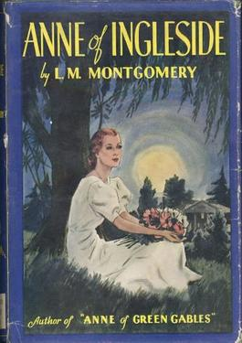

Anne of Ingleside is a children's novel by [Canadian](https://en.wikipedia.org/wiki/Canadians" \o "Canadians) author [Lucy Maud Montgomery](https://en.wikipedia.org/wiki/Lucy_Maud_Montgomery" \o "Lucy Maud Montgomery).[[1]](https://en.wikipedia.org/wiki/Anne_of_Ingleside" \l "cite_note-1) It was first published in July 1939[[2]](https://en.wikipedia.org/wiki/Anne_of_Ingleside" \l "cite_note-2) by McClelland and Stewart (Toronto) and the Frederick A. Stokes Company (New York).[[3]](https://en.wikipedia.org/wiki/Anne_of_Ingleside" \l "cite_note-3) It is the tenth of eleven books that feature the character of Anne Shirley,[[4]](https://en.wikipedia.org/wiki/Anne_of_Ingleside" \l "cite_note-4) and Montgomery's final published novel.[[5]](https://en.wikipedia.org/wiki/Anne_of_Ingleside" \l "cite_note-5)

Chronologically, Anne of Ingleside precedes [Rainbow Valley](https://en.wikipedia.org/wiki/Rainbow_Valley" \o "Rainbow Valley), which was published years earlier. In addition, a short story collection [The Blythes Are Quoted](https://en.wikipedia.org/wiki/The_Blythes_Are_Quoted" \o "The Blythes Are Quoted), written in 1941/42 yet not published until 2009, concludes the Anne stories.

RAINBOW VALLEY

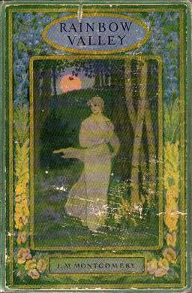

Rainbow Valley (1919) is the seventh book in the chronology of the [Anne of Green Gables](https://en.wikipedia.org/wiki/Anne_of_Green_Gables" \o "Anne of Green Gables) series by [Lucy Maud Montgomery](https://en.wikipedia.org/wiki/Lucy_Maud_Montgomery" \o "Lucy Maud Montgomery), although it was the fifth book published. While [Anne Shirley](https://en.wikipedia.org/wiki/Anne_Shirley" \o "Anne Shirley) was the main protagonist of the previous books, this novel focuses more on her six children and their interactions with the children of Anne's new neighbour, [Presbyterian](https://en.wikipedia.org/wiki/Presbyterian" \o "Presbyterian) [minister](https://en.wikipedia.org/wiki/Minister_of_religion" \o "Minister of religion) John Meredith. The work draws heavily on Montgomery's own life in the [Leaskdale Manse](https://en.wikipedia.org/wiki/Leaskdale_Manse" \o "Leaskdale Manse), where she wrote a large number of books.[[1]](https://en.wikipedia.org/wiki/Rainbow_Valley" \l "cite_note-Clement2015-1)

The book is dedicated: "To the memory of Goldwin Lapp, Robert Brookes and Morley Shier who made the supreme sacrifice that the happy valleys of their home land might be kept sacred from the ravage of the invader." This refers to [World War I](https://en.wikipedia.org/wiki/World_War_I" \o "World War I), which is the main theme of the next and final book in the series, [Rilla of Ingleside](https://en.wikipedia.org/wiki/Rilla_of_Ingleside" \o "Rilla of Ingleside).

RILLIA OF INGLESIDE

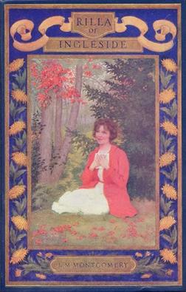

Rilla of Ingleside (1921) is the eighth of nine books in the [Anne of Green Gables](https://en.wikipedia.org/wiki/Anne_of_Green_Gables" \o "Anne of Green Gables) series by [Lucy Maud Montgomery](https://en.wikipedia.org/wiki/Lucy_Maud_Montgomery" \o "Lucy Maud Montgomery), but was the sixth "Anne" novel in publication order. This book draws the focus back onto a single character, [Anne](https://en.wikipedia.org/wiki/Anne_Shirley" \o "Anne Shirley) and [Gilbert](https://en.wikipedia.org/wiki/Gilbert_Blythe" \o "Gilbert Blythe)'s youngest daughter Bertha Marilla "Rilla" Blythe. It has a more serious tone, as it takes place during [World War I](https://en.wikipedia.org/wiki/World_War_I" \o "World War I) and the three Blythe boys—Jem, Walter, and Shirley—along with Rilla's sweetheart Ken Ford and playmates Jerry Meredith and Carl Meredith—end up fighting in Europe with the [Canadian Expeditionary Force](https://en.wikipedia.org/wiki/Canadian_Expeditionary_Force" \o "Canadian Expeditionary Force).

THE BLYTHES ARE QUOTED

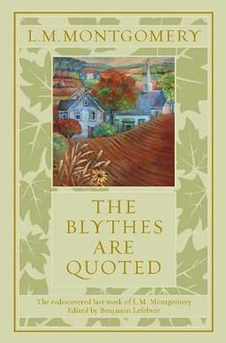

The Blythes Are Quoted is a book completed by [L. M. Montgomery](https://en.wikipedia.org/wiki/L._M._Montgomery" \o "L. M. Montgomery) (1874–1942) near the end of her life but not published in its entirety until 2009. It is her eleventh book to feature [Anne Shirley Blythe](https://en.wikipedia.org/wiki/Anne_Shirley" \o "Anne Shirley), who first appears in her first and best-known novel, *[Anne of Green Gables](https://en.wikipedia.org/wiki/Anne_of_Green_Gables" \o "Anne of Green Gables)* (1908), and then in [Anne of Avonlea](https://en.wikipedia.org/wiki/Anne_of_Avonlea" \o "Anne of Avonlea) (1909), [Chronicles of Avonlea](https://en.wikipedia.org/wiki/Chronicles_of_Avonlea" \o "Chronicles of Avonlea) (1912), [Anne of the Island](https://en.wikipedia.org/wiki/Anne_of_the_Island" \o "Anne of the Island) (1915), [Anne's House of Dreams](https://en.wikipedia.org/wiki/Anne's_House_of_Dreams" \o "Anne's House of Dreams) (1917), [Rainbow Valley](https://en.wikipedia.org/wiki/Rainbow_Valley" \o "Rainbow Valley) (1919), [Further Chronicles of Avonlea](https://en.wikipedia.org/wiki/Further_Chronicles_of_Avonlea" \o "Further Chronicles of Avonlea) (1920), [Rilla of Ingleside](https://en.wikipedia.org/wiki/Rilla_of_Ingleside" \o "Rilla of Ingleside) (1921), [Anne of Windy Poplars](https://en.wikipedia.org/wiki/Anne_of_Windy_Poplars" \o "Anne of Windy Poplars) (1936), and [Anne of Ingleside](https://en.wikipedia.org/wiki/Anne_of_Ingleside" \o "Anne of Ingleside) (1939). It consists of an experimental blend of fifteen short stories, forty-one poems, and numerous vignettes featuring Anne and members of her family discussing her poetry. The book focuses on small-town life in Glen St. Mary, [Prince Edward Island](https://en.wikipedia.org/wiki/Prince_Edward_Island" \o "Prince Edward Island), and is divided into two halves: one preceding the events of the First World War of 1914–1918 and one relating incidents after the war, up to and including the beginning of the Second World War of 1939–1945.

ANNE’S HOUSE OF DREAMS

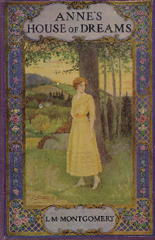

Anne's House of Dreams is a novel by [Canadian](https://en.wikipedia.org/wiki/Canadians" \o "Canadians) author [Lucy Maud Montgomery](https://en.wikipedia.org/wiki/Lucy_Maud_Montgomery" \o "Lucy Maud Montgomery). It was first published in 1917 by [McClelland, Goodchild and Stewart](https://en.wikipedia.org/wiki/McClelland_and_Stewart" \o "McClelland and Stewart).

The novel is from a series of books written primarily for girls and young women, about a young girl named [Anne Shirley](https://en.wikipedia.org/wiki/Anne_Shirley" \o "Anne Shirley). The books follow the course of Anne's life. It is set principally on Canada's [Prince Edward Island](https://en.wikipedia.org/wiki/Prince_Edward_Island" \o "Prince Edward Island), Montgomery's birthplace and home for much of her life.

The series has been called classic children's literature, and has been reprinted many times since its original publication.

Anne's House of Dreams is book five in the series, and chronicles Anne's early married life, as she and her childhood sweetheart [Gilbert Blythe](https://en.wikipedia.org/wiki/Gilbert_Blythe" \o "Gilbert Blythe) begin to build their life together.